Pairwise testing – very good (~95% coverage)
- groups pairs of inputs
+ significantly reduces test cases
+ good coverage
+ scales well
- not total coverage
- time consuming!
- difficult to understand
- use pict to generate the inputs
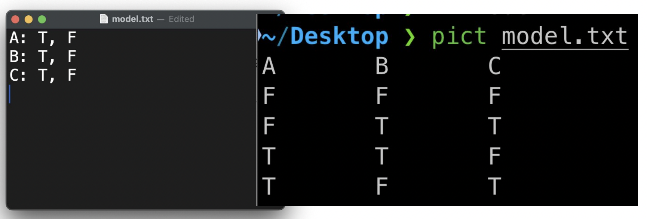

N-wise testing
- groups n inputs

state transition testing (mid)
- mapping out all state transitions of the system
+ great for UI testing
+ good for testing sequences of events
- useless if states aren’t a factor
- useless if infinite amount of states
- can be complex
- Can’t capture dynamic behaviour
- Risk of missing a state and/or transition

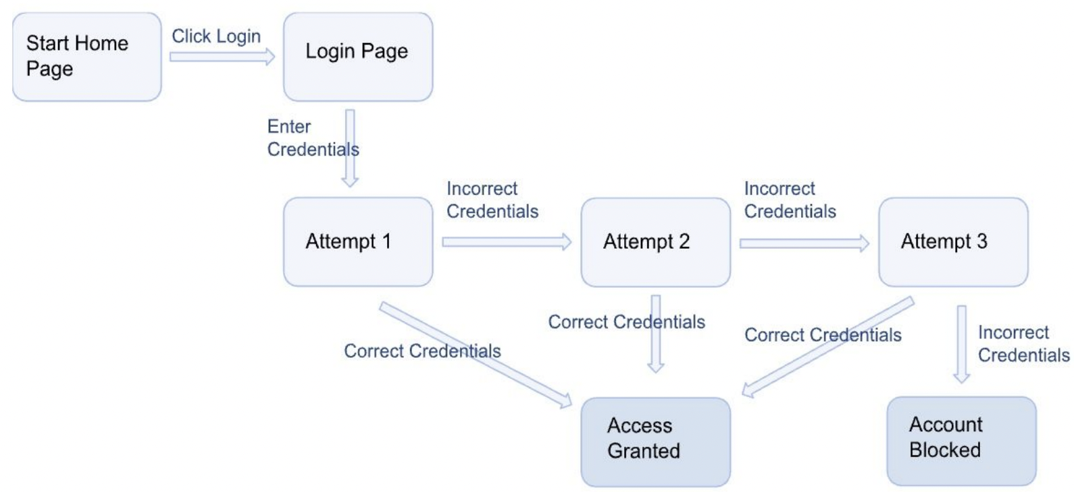

error guessing testing (mid)
- using intuition and experience to guess a bug
+ can find common bugs
- security hard to exec
- expensive if an expert is hired
- doesn’t work if you’re already experienced

